Interview with Isaac Tyson on his 90th birthday
Background. This interview took place on 3 October 1972 in New Plymouth, on the occasion of Isaac Tyson’s 90th birthday. Ross Callaghan (R) interviewed his grandfather Isaac Tyson (I) to find details about his life in New Zealand and England. At the time Ross was 25 and lived in Northcote. Isaac had been living for part of each year with his daughters Madge Callaghan (Northcote), Joan Williams (Timaru) and Norma Bayly (New Plymouth). Isaac died on the 19th May 1974 in New Plymouth.
The interview can be heard here:
https://drive.google.com/open?id=0B7B2M-rOkUlvNE5mNkVPbkdsMkU
The history of the Tyson family can be downloaded here:
https://drive.google.com/open?id=0B7B2M-rOkUlvdDMxQ1hBMDVQV00
Details of the wider family and links to many family resources can be obtained from Ross and Kathy Callaghan’s family website: callaghans.yolasite.com

R. Hello listeners, this is Radio New Zealand. And this is the Northcote branch of Radio New Zealand on this very, very, beautiful fine day here in New Plymouth. We have to come to interview Mr I Tyson. Mr Tyson, how old are you today?
I. I’m 90 today.
R. 90 today! And how does it feel to be 90?
I. Well it feels to be 90!
R. What do you mean by that?
I. Well I just feel I’m not as young as I used to be. That’s all. I’m afraid I won’t be able to be here much longer.
R. Oh I don’t know about that, Mr Tyson. We sort of feel that you’re still a young fella yet.
I. Some days I do. Some days I do, but this morning I woke up and I felt very ill, but I’m not so bad just now.
R. That’s good. Now we feel that anybody that’s 100, we call him an old fella, but people like you who are only 90….
I. I’m only a young man, yet!
R. That’s right. We feel you’re a young fella.
I. All the same I’ve seen quite a lot of things in my time.
R. Have you? Like what?
I. Oh, different things, different places. I’ve seen a lot of New Zealand, and I know quite a bit about England.
R. Which part of England did you come from?
I. From the north of England. Cumberland. The Lake District.
R. Can you speak anything in Cumberland?
I. I certainly can. “Never again Eddie, Never again. If I cain’t have a lad that will court me alain. And just have yan sweetheart and me be that yan, I’ll bide as I is till I dee”.
R. Dear me! What on earth did that say?
I. Well, it means that “Never again, Never again. If I can’t have a lad that will court me alone. And just have one sweetheart and me be that one, I’ll stay as I am till I die”.
R. I see. Well it certainly sounder rather strange to me. Now, My Tyson, what about the weather? You’ve noticed that in Northcote they get such beautiful weather…
I. The weather’s warmer here than it is in England.
R. Ah yes. But what about in Northcote. Would you say that Northcote would have the best weather in the world?
I. I wouldn’t say that.
R. But we’ve noticed that it only rains once a year in Northcote!
I. Oh I wouldn’t say that either, but, taking it on the whole, It’s warmer there than any other part that I’ve been in New Zealand.
R. I see, and where abouts in New Zealand are you at the moment?
I. I’m in New Plymouth.
R. And who are you staying with?
I. I’m staying with my youngest daughter, Mrs Bayly. And both her and Mick are looking after me very, very well.
R. And what about your other daughters? What are they called?
I. Oh I’m jolly pleased to have the other two daughters with me at the moment.
R. What are their names?
Mrs Callaghan and Mrs Williams. One is from Timaru and one is from Northcote.
R. Aren’t they lovely?
I. They certainly are. And they’re looking after like as if I was a baby.
R. Now it’s your 90th birthday, Mr Tyson. What’s going to happen today?
I. I don’t know. It seems there’s going to be a bit of a party or something, with all the chairs and things around the room.
R. Yes, it also looks like there’s going to be a bit of a feed doesn’t there?
I. Naturally. But I don’t eat as much now as I used to do.
R. Why’s that?
I. Don’t know. Don’t feel like it.
R. I see. Now, what do you do most of the day?
I. Read the talking books.
R. What are they like?
I. Oh, they’re good. Very good. Some of them are really, really good. In fact, I read Oliver Twist a fortnight ago and I remember reading it when I was a boy.
R. Is that right. Fancy that! Was it still the same?
I. Look you. I couldn’t tell you. I wondered what Oliver Twist was about last time. I’d forgotten it. So long since I read it.
R. Fancy that. And what are some of the other books you are getting to read?
I. Some of them are not supposed to be read in mixed company!
R. Dear me, Mr Tyson! Now what else can we talk about? When did you come to New Zealand?
I. Oh I came to New Zealand in 1908.
R. Oh yes, and how did you get here?
I. On a steamer. The Oratava. We left London on December 7th 1907, and there was a big storm in the English Channel that night and a vessel went down with 13 hands on board. We were 19 hours late getting in to Plymouth and we never made that time up before we got to Sydney. We were supposed to turn ship in Sydney to the Moana but we were 3 hours behind time so we had to stay a week in Sydney. My cobber and I got a bed for a shilling a night and we got all our meals wherever we were. We had to look all around Sydney and we paid sixpence for a meal. Most beautiful meal ever I had in my life. Anyhow, I landed in Wellington on the first week in February 1908.
R. 1908. And have you been in New Zealand ever since?
I. No, I went home in 1912 with my cousin. He was badly injured in the mine. He wanted company to go home with him. And time I was home in England I got married and I came back here. In 1917.
R. And what have you done since you came back in 1917?
I. I worked in the mines. I worked in the state coal mines for 36 years. And the last 20 years I was underviewer. Next to the Mine Manager.
R. That’s not the same as undertaker is it?
I. No, No. No!
R. And what does an underviewer do in a mine?
I. He looks after everybody. Plans out the work and looks to see it’s done properly. He’s the boss.
R. I see. And where abouts was this mine?
I. Rewanui.
R. Where’s that?
I. 9 miles out of Greymouth.
R. On the sunny West Coast?
I. On the West Coast of the South Island.
R. I see. And I’ve heard that the weather there is beautiful!
I. Oh, very wet. Anyhow, after I’d been there about 36 years I took ill and they put me in the Greymouth hospital and the Doctor there said “Don’t you go down the mine any more. If you’re a lucky man you’ll be alive in 6 months time. You’ve got cancer”. Here I am. Nearly 30 years since then and I’m still alive!
R. That’s pretty good isn’t it?
I. I couldn’t have had cancer.
R. And then what happened? When did you retire? What year was that?
I. 1945.
R. And where did you retire to?
I. We went to live in New Brighton – 5 miles out of Christchurch. I used to play bowls and had a lovely time there till the wife died. I took ill again, and my daughter up in Northcote came and took me up there and they persuaded me to sell my house there. I did that and I’ve lived with my daughters ever since.
R. Aren’t you lucky to have such lovely daughters?
I. I certainly am, and I appreciate it.
R. Now what about your grandchildren. Have you got any grandchildren?
I. I’ve got 4 grandchildren. 3 of them are married.
R. One isn’t. Who’s he?
I. Ross Callaghan. Ross Graham Callaghan.
R. Oh yes. I don’t know him very well.
I. He’s the only one not married. Seems to be hard to please. The other 3 are married but they’ve got no children.
R. I see. Now what are their names?
I. Mr and Mrs Brian Callaghan who are at the moment in England on a wedding tour, and they’re having a real good time, and I’m pleased to hear it, and I wish them all the best in the world. And I’m jolly glad to have 4 grandchildren, and the only thing I’m waiting for now is some great-grandchildren.
R. Now what about the other grand-children – the Williams grand-children.
I. I’m staying with my youngest daughter now. Mrs Norma Bayly. She’s got no children. She used to be a nurse. She’s looking after me well. My eldest daughter, Madge, Mrs Callaghan, she’s got 2 sons. The youngest son is Brian who is at the moment over in Scotland and having a real good time, and I’m pleased to hear it.
R. Fair enough, now what about the other ones, the Williams children? What are their names?
I. The Williams children are Lex and Pauline.
R. And who did Lex marry?
I. Leonie Lowe.
R. And where abouts do they live now?
I. They are living in Wellington at the moment.
R. And what does he do?
I. He’s a civil servant. He works for the Railway Department. And he got promoted from Christchurch to Wellington. At the moment they’re waiting to buy a house. Pauline, she’s married a farmer down in Waimate.
R. Fancy that. You wouldn’t have thought she’d have been able to take that life.
I. She seems to be very happy and all the rest of it.
R. Very nice. Now do have any birthday message to spread to the world? On your 90th birthday.
I. I’m jolly glad to be here in New Zealand. I wouldn’t go back to England except for the weekend!
R. You’d like to walk would you?
I. New Zealand will do me. It’s a lovely country, and the people are very, very nice.
R. Yes, well we’ve noticed this. It takes them a while to become New Zealandised when they get from England.
I. I’m nearly a New Zealander now – nearly a kiwi. I’ve been here that long now - 65 years and I’m just about a kiwi now.
R. And because you’re a kiwi we’ve clipped your wings and you don’t want to go flying away.
I. No I don’t want to go home. I’ve got no inclination to go home to England now. I’ve only got one sister alive. She’s my youngest sister.
R. What’s her name?
I. Her name’s Belle.
R. Where abouts in England does she live?
I. She lives in Arlecdon. That’s in Cumberland.
R. And could you tell us a little bit about Cumberland. What’s it like there?
I. Oh, Cumberland’s lovely country. They’ve got the highest mountain, the smallest church, the deepest lake and the smallest railway in the whole of England.
R. I seem to remember something about a church that got snowed under. Could you tell us that story?
I. In 1895 there was a wedding in the little village of Arlecdon and there was also a blizzard. And, of course, the custom there is when a wedding’s on, the boys and girls follow the cabs to the church and the people in the cabs throw coppers to them. I was one of the boys that was following the wedding party and it got to the Sun Inn –that’s half way between the church and where I lived, and I couldn't get to the church and I couldn’t get home. My father had to come and look for me and he gave me a blimmin’ good hiding for being out in the storm. Anyhow, the cabs got the marriage party to the church and the vicar was there and he married them but they had to stay in church all night. There was 10 feet of snow all over the place and they couldn’t get out. They had to stay in the church all night and they were dug out next day. And the unfortunate part of it was the girl Mabel Snellars? died 12 months after she was married, giving birth to a baby. They lived in a big house called Rheda. They weren’t involved with workers. They were supposed to be better class people.
R. Well, Mr T. You’re certainly full of stories, aren’t you? You’ve got lots of stories there.
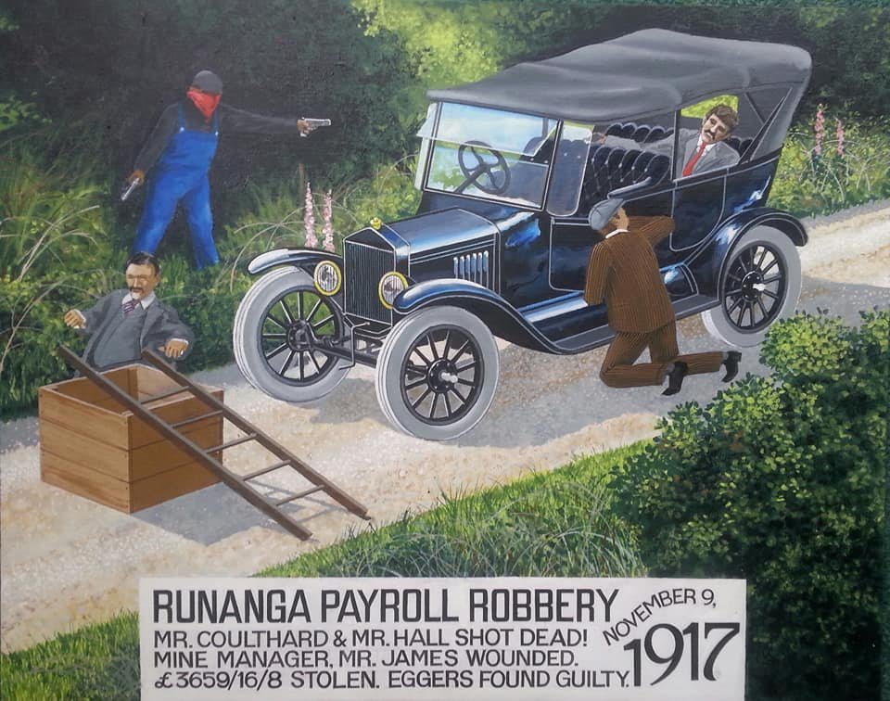
I. Time I was over on the West Coast, in 1917, the paymaster went in to Greymouth the get the pay, to pay the miners, you know. And there was a chap was in the bush waiting for him and he put out branches all over the road, and of course, the cab had to stop. The taxi. They’d picked up the superintendent of the coal mine in Greymouth and he was in the motor car with them. And the fellow in the bush put branches all over the road and the motor car had to stop. And he came out of the bush with 2 pistols; one in each hand and demanded the pay. They wouldn’t give him the pay, so he shot them dead. Both of them. Of course, the superintendent of the coal mine was getting out of the car, and he shot him too, but he only shot him through the leg. He raised the alarm, and before long we were all out in the bush looking for the murderer, but they never found him. He got across the bush to the railway at Midland line and caught the train, and coach – there wasn’t a train right through in those days – and got into Christchurch. Of course, when he got into Christchurch he went to stay in the hotel. The murder was all the talk of the town and he started talking about the murder to the barmaid. The barmaid kept on talking to him. She thought “He’s talking a bit wildly”, so she told the detective about it. The detective started enquiring about this chap, and they found out that he had been on the West Coast that day. And anyhow, they found a few more suspicious circumstances about him and they arrested him, and they found all the money from the bank in his possession. So they arrested him, tried him and hung him.

R. Oh, sounds like the Wild West!
I. That was in 1917.
R. Well I hope it’s not like that today.
I. Eggers. Chap called Eggers
R. Well thank you very much Mr Tyson. This has been a very, very valuable and interesting interview and we would like to wish you, on behalf of New Zealand, a very happy birthday.
I. Thank you very, very much.

